TASK 1:

FOR BUFFER 1:
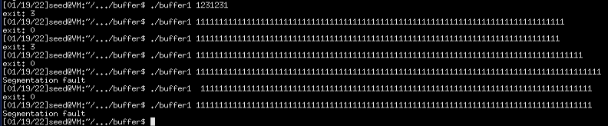
With around 80-85 characters, exit is 0. Segmentation fault appears from character 86 onwards.

FOR BUFFER 2:

size of buffer: 100
Segmentation fault: 106

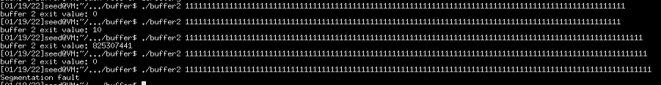
numbers of arguments: 100,99,104,105,106

FOR BUFFER 3

size of buffer: 28

Segmentation fault: 34
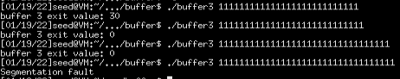
numbers of arguments: 27,28,33,34
TASK2:
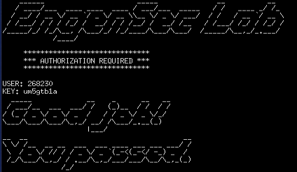
My student ID: 268230
KEYGEN 1

KEYGEN 3:
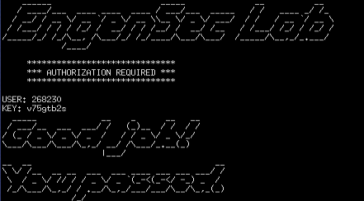
Couldn't break into Keygen 2 because there was no “main” function to break into :)

